Tim Lewis
TimLewis1207@gmail.com
https://www.lewisventure.com/Media.html

Biographies

~200 Words – Tim Lewis manages rocket programs by day, and collects hobbies by night. Writing has been the longest running hobby, going back to middle school and first place in a Halloween story contest. He took creative writing at Purdue, but his public works have all been scholastic and technical. In the years following, there has been an accumulation of short stories and scenes brewing that few have seen beyond his laptop. Tim leans toward Sci Fi, Urban Fantasy and Noir, where each contain an element of humor and sarcasm from a life spent as a smart ass. He published his first fiction work, Switch, in 2019 and additional short stories in various anthologies. He continues to write and submit as he aspires to his favorite quote by Benjamin Franklin, “If you wou’d not be forgotten / As soon as you are dead and rotten, / Either write things worth reading, / or do things worth the writing.” For more on Tim and his work, go to LewisVenture.com.

~50 Words – Tim Lewis manages rocket programs by day, and collects hobbies by night. Tim leans toward Sci Fi, Urban Fantasy and Noir, where each contain an element of humor from a life spent as a smart ass. For more on Tim and his work, go to LewisVenture.com.

100 Character – Notes of Sci Fi or Urban Fantasy, with a voluptuous plenitude of humor and sarcasm. LewisVenture.com

Social Media
Amazon - https://amazon.com/author/timothymlewis
Good Reads - https://www.goodreads.com/user/show/148257266-tim-lewis
Facebook - https://www.facebook.com/LewisVentureLLC/
Instagram - https://www.instagram.com/timlewis1207/
Twitter - https://twitter.com/TimLewisDM
LinkedIn - http://www.linkedin.com/in/timothymlewis
Books 2 Read - https://books2read.com/TimLewis
Website - https://www.lewisventure.com/Author.html

Headshots
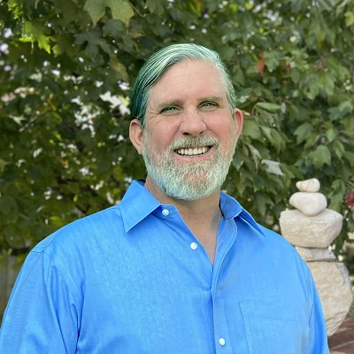

Bibliography / Catalog / Oeuvre / Corpus / Canon / Stack / Meanderings

Switch
Published 2019 JordanCon Anthology: So You Want Stories

Accomplice
Published 2022 Inked Anthology: Hidden Villains

Twelve
Published 2022 JordanCon Anthology: Neither Beginnings Nor Endings

Loupers
Published 2023 Inked Anthology: Hidden Villains: Arise

Adivino
Published 2023 Inked Anthology: Noncorporeal

Glimmer
Published 2024 Inked Anthology: Hidden Villains: Betrayal

